**Exercise 1: Configuring a Basic Spring Application**

Main.java

package org.example;  
  
import org.example.service.BookService;  
import org.springframework.context.ApplicationContext;  
import org.springframework.context.support.ClassPathXmlApplicationContext;  
  
public class Main {  
 public static void main(String[] args) {   
 ApplicationContext context = new ClassPathXmlApplicationContext("applicationContext.xml");  
  
 BookService bookService = (BookService) context.getBean("bookService");  
  
 bookService.addBook("My new book");  
 }  
}

BookRepository.java

package org.example.repository;  
  
public class BookRepository {  
 public void saveBook(String title) {  
 System.*out*.println("Book: " + title + " successfully saved");  
 }  
}

BookService.java

package org.example.service;  
  
import org.example.repository.BookRepository;  
  
public class BookService {  
 private BookRepository bookRepository;  
  
 public void setBookRepository(BookRepository bookRepository) {  
 this.bookRepository = bookRepository;  
 }  
  
 public void addBook(String title) {  
 System.*out*.println("Adding book: " + title);  
 bookRepository.saveBook(title);  
 }  
}

applicationContext.xml

<?xml version="1.0" encoding="UTF-8"?>  
<beans xmlns="http://www.springframework.org/schema/beans"  
 xmlns:xsi="http://www.w3.org/2001/XMLSchema-instance"  
 xsi:schemaLocation="http://www.springframework.org/schema/beans  
 http://www.springframework.org/schema/beans/spring-beans.xsd">  
  
 <bean id="bookRepository" class="org.example.repository.BookRepository"/>  
  
 <bean id="bookService" class="org.example.service.BookService">  
 <property name="bookRepository" ref="bookRepository"/>  
 </bean>  
  
</beans>

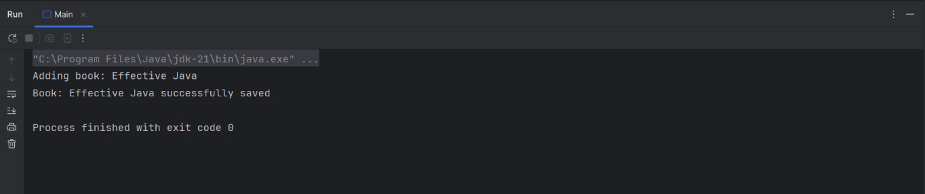

**Exercise 2: Implementing Dependency Injection**

Main.java

package org.example;  
  
import org.example.service.BookService;  
import org.springframework.context.ApplicationContext;  
import org.springframework.context.support.ClassPathXmlApplicationContext;  
  
public class Main {  
 public static void main(String[] args) {   
 ApplicationContext context = new ClassPathXmlApplicationContext("applicationContext.xml");  
  
 BookService bookService = (BookService) context.getBean("bookService");  
  
 bookService.addBook("This is another new book");  
 }  
}

BookRepository.java

package org.example.repository;  
  
public class BookRepository {  
 public void saveBook(String title) {  
 System.*out*.println("Book: " + title + " successfully saved");  
 }  
}

BookService.java

package org.example.service;  
  
import org.example.repository.BookRepository;  
  
public class BookService {  
 private BookRepository bookRepository;  
  
 public void setBookRepository(BookRepository bookRepository) {  
 this.bookRepository = bookRepository;  
 }  
  
 public void addBook(String title) {  
 System.*out*.println("Adding book: " + title);  
 bookRepository.saveBook(title);  
 }  
}

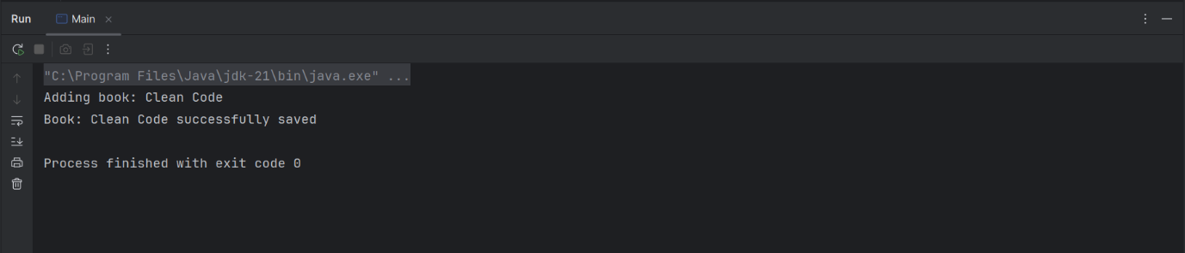

**Exercise 4: Creating and Configuring a Maven Project**

Pom.xml

<?xml version="1.0" encoding="UTF-8"?>  
<project xmlns="http://maven.apache.org/POM/4.0.0"  
 xmlns:xsi="http://www.w3.org/2001/XMLSchema-instance"  
 xsi:schemaLocation="http://maven.apache.org/POM/4.0.0 http://maven.apache.org/xsd/maven-4.0.0.xsd">  
 <modelVersion>4.0.0</modelVersion>  
  
 <groupId>org.example</groupId>  
 <artifactId>LibraryManagement</artifactId>  
 <version>1.0-SNAPSHOT</version>  
  
 <properties>  
 <maven.compiler.source>21</maven.compiler.source>  
 <maven.compiler.target>21</maven.compiler.target>  
 <project.build.sourceEncoding>UTF-8</project.build.sourceEncoding>  
 </properties>  
  
 <dependencies>  
  
 <dependency>  
 <groupId>org.springframework</groupId>  
 <artifactId>spring-context</artifactId>  
 <version>6.2.8</version>  
 </dependency>  
  
 <dependency>  
 <groupId>org.springframework</groupId>  
 <artifactId>spring-aop</artifactId>  
 <version>6.2.8</version>  
 </dependency>  
  
 <dependency>  
 <groupId>org.springframework</groupId>  
 <artifactId>spring-webmvc</artifactId>  
 <version>6.2.8</version>  
 </dependency>  
  
 <dependency>  
 <groupId>javax.servlet</groupId>  
 <artifactId>javax.servlet-api</artifactId>  
 <version>3.1.0</version>  
 </dependency>  
  
  
 </dependencies>  
  
 <build>  
 <plugins>  
 <plugin>  
 <groupId>org.apache.maven.plugins</groupId>  
 <artifactId>maven-compiler-plugin</artifactId>  
 <version>3.14.0</version>  
 <configuration>  
 <source>1.8</source>  
 <target>1.8</target>  
 </configuration>  
 </plugin>  
 </plugins>  
 </build>  
  
</project>